**Current Structure of Our Database**

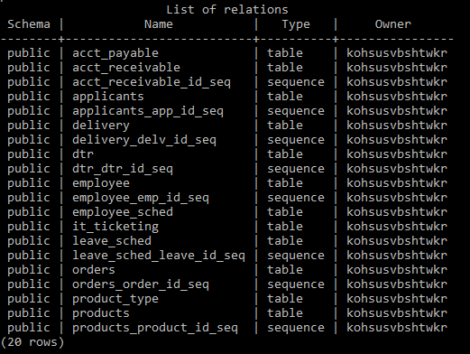

1) acct_payable Note: included an example content for display

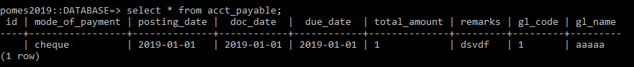

2) acct_receivable Note: included an example content for display

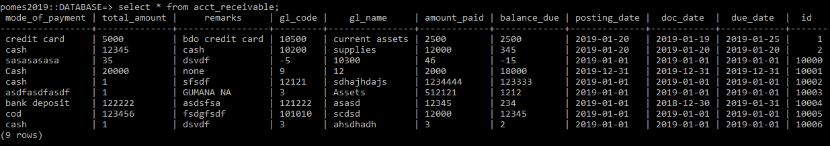

3) applicants Note: included an example content for display



4) delivery

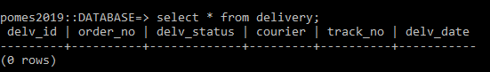

5) DTR Note: included an example content for display

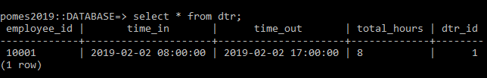

6) employee Note: included an example content for display



7) employee_sched Note: included an example content for display

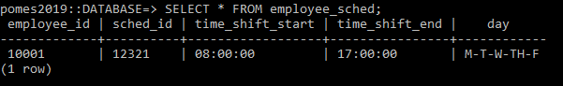

8) it_ticketing Note: included an example content for display



9) leave_sched Note: included an example content for display

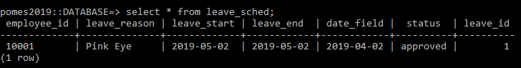

10) orders Note: included an example content for display



11) product_type Note: included an example content for display

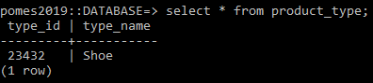

12) products

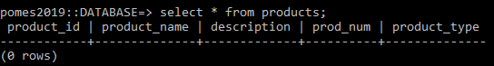

NOTE: Linagyan ko na po ng laman halos lahat para ma testing nyo po agad ung connection nyo sa database at mkapag fetch kayo ng data from it. Para dun po sa mga walang laman pwede nyo po palagyan kung gusto pm nyo lang po ung database managers